Year  Nursery | Autumn 1 | Autumn 2 | Spring 1 |  |  | Spring 2 | Summer 1 | Summer 2
focus | Vocabulary development  RWInc Story programme | Vocabulary development  RWInc Story programme | Nursery rhymes  Story telling orally (Story stones) (Talking Toolkit)  RWInc Story programme |  |  | Nursery rhymes  Story telling orally (Story stones) (Talking Toolkit)  RWInc Story programme | Read Write Inc sounds (5 a week)  Re-enacting stories in continuous provision | Read Write Inc sounds (5 a week)  Re-enacting stories in continuous provision
Writing  skills | Simple mark making using a variety of different tools | Developmental shape awareness | Dough disco |  |  | Developmental shape awareness | RWI letter formations  Name writing | RWI letter formations  Name writing
P  Poetry | 5 Shiny Conkers |  |  | Mix a Pancake (Christina Rosetti) |  |  | TBC
Nursery rhymes | Old MacDonald had a farm  Hickory dickory dock |  |  | I’m a little teapot  Miss Polly had a dolly |  |  | If you’re happy and you know it  5 little ducks
Year Nursery Reading: During the year the following stories will be shared and enjoyed as a class.
Oi Frog! |  |  | 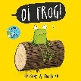 |  | Penguin |  |  |  | 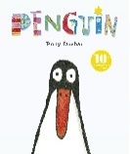
Owl Babies |  |  | 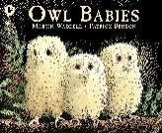 |  | Monkey and Me |  |  |  | 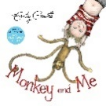
Shark in the Park |  |  | 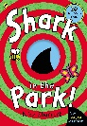 |  | Susan Laughs |  |  |  | 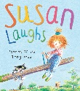
Where’s Bear? |  |  | 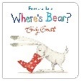 |  | Solomon Crocodile |  |  |  | 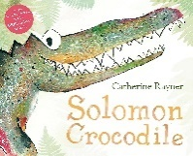
The Three Little Pigs |  |  | 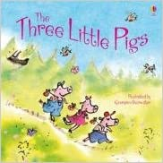 |  | The Gingerbread Man |  |  |  | 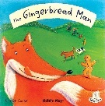
We’re Going on a Bear Hunt |  |  | 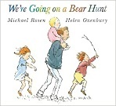 |  | Lost and Found |  |  |  | 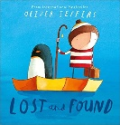
So Cosy |  |  | 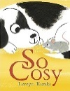 |  | Walking Through the Jungle |  |  |  | 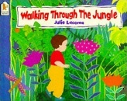
So Much! |  |  |  |  | Whose Toes Are Those? |  |  |  | 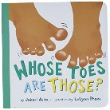
Something Beginning with Blue |  |  | 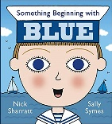 |  | Solomon and Mortimer |  |  |  | 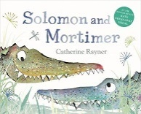
Goldilocks and the Three Bears |  |  | 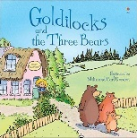 |  | The Three Billy Goats Gruff |  |  |  | 