Curriculum Intent
In English we aim to ‘Break the limits – go beyond!’

(Our slogan was created by Ruben in Y5)

A high-quality education in English will teach pupils to speak and write fluently so that they can communicate their ideas and emotions to others and through their reading and listening, others can communicate with them. Through reading in particular, pupils have a chance to develop culturally, spiritually, emotionally, intellectually and socially. Reading also enables pupils both to acquire knowledge and to build on what they already know. All the skills of language are essential to participating fully as a member of society with a growth mindset mentality.
All learners, including the most disadvantaged pupils and pupils with SEND, are provided with the knowledge, skills and cultural capital they need to catch up quickly and succeed in life.
At St Joseph’s our English curriculum follows the guidelines from the 2014 National curriculum. We aim to promote high standards in English by equipping pupils with a strong command of the spoken and written word and to develop a love of literature through reading for enjoyment. We believe that English is the cornerstone to the entire curriculum and it is therefore embedded within all of our lessons and teaching. We believe, ‘Every child has the right to an education’ (Article 28).

Due to Covid our curriculum is now designed to rapidly repair learning and close gaps. A clear strategy for pupil progression is in place to take pupils back to where they are at and intervention is carefully planned in order to ‘keep up’ so that pupils do not need to ‘catch up’. Outstanding teaching ensures all children follow a mastery approach within the classroom setting and quality first teaching and TA support is vital so that learners can access all parts of the English curriculum.

Curriculum Implementation
Phonics
At St Joseph’s Primary School, we follow the Read Write Inc phonics programme. Read Write Inc. Phonics teaches children to read accurately and fluently with good comprehension. They learn to form each letter, spell correctly, and compose their ideas step-by-step. Children learn the English alphabetic code: first they learn one way to read the 40+ sounds and blend these sounds into words, then learn to read the same sounds with alternative graphemes. They experience success from the very beginning. Lively phonic books are closely matched to their increasing knowledge of phonics and ‘tricky’ words and, as children re-read the stories, their fluency increases. Children’s composition (ideas, vocabulary and grammar) is developed by drawing on their own experiences and talking about the stories they read. The children write most days, rehearsing out loud what they want to spell the spelling the words using the graphemes and ‘tricky’ words they know. This is the timetables we follow to deliver the phonic programme. We believe our children need daily practice of the crucial sounds to blend words to become more fluent readers. In addition to this we include one designated day for writing where the children can use their imagination along with their phonic knowledge to build well-structured sentences. This day gives the children the opportunity to plan and write a successful piece of writing.
Five-day timetable
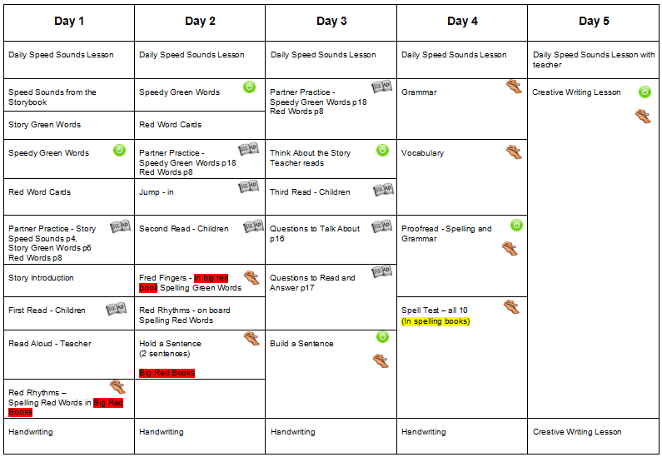

Three-day timetable
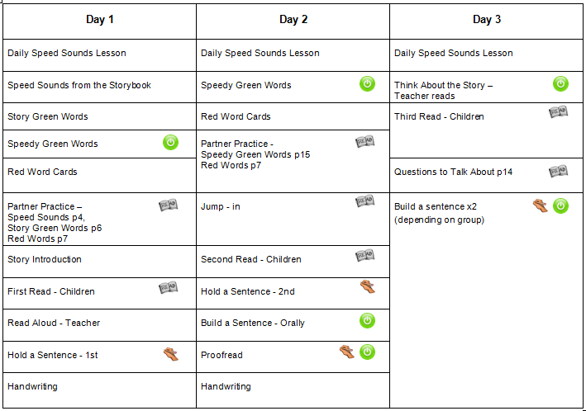

They practise handwriting every day: sitting at a table comfortably, they learn Along with a thought-provoking introduction, prompts for thinking out loud and discussion, children are helped to read with a storyteller’s voice.
correct letter formation and how to join letters speedily and legibly.

The children practise handwriting every day: sitting at a table comfortably, they learn correct letter formation and how to join letters speedily and legibly. From year two, we use the handwriting scheme ‘Handwriting Today’ by Helen Woods by showing the children how to clearly form their letters using rhymes and pictures.
Speaking and Listening
Throughout the school opportunities to develop pupil’s spoken language in a range of contexts underpins the development of reading and writing. Pupils are encouraged to speak clearly, confidently and with expression in order to communicate their ideas and feelings. They are taught to understand and use the conventions for discussion and debate.
Pupils develop their ability to explain their understanding of books and other reading, and to prepare their ideas before they write. They are encouraged to discuss their ideas in order to make sense of their learning.
Pupils are given many opportunities through drama, role play, performances, reading out loud, presentations and debate in many areas of the curriculum on a daily basis.
Here at St. Joseph’s we believe in Philosophy for Children, sometimes abbreviated to P4C, it is a movement that aims to teach reasoning and argumentative skills to children. We aim to deliver this important approach at least once per half term.

Reading
Reading is an integral part of the curriculum at St Joseph’s and it is our vision to ensure that all children receive the opportunity to read and engage in high quality and relevant literature. At St Joseph’s children learn to develop their word reading and comprehension skills in order to become fluent and reflective readers, enabling them to foster a long-term love of reading. In addition to this, each year group has a reading lesson 3 times a week where they are taught to improve their fluency and comprehension of planned texts (see year group overviews below).
We aim for children to be able to read widely, confidently and to a high standard in a range of subjects. We want children to foster a love of reading and acquire a wide vocabulary of written and spoken language.
In EYFS there is a core book collection. Nursery and Reception follow a story cycle where books are repeated to enable children to retell and sequence the story confidently using elements of story language. In addition to this there is a cycle or nursery rhymes taught during daily rhyme time sessions, where the aim is that children are able to confidently recite one nursery rhyme per half term. We send copies of the nursery rhymes taught home to parents for repetition and reinforcement.
In Nursery the most able children start their reading journey by telling stories using wordless picture books. This helps children to understand the structures of stories. In Reception, when children are confident with their set 1 sounds they then take RWI books home focusing on the sounds they are working on in class. This encourages these early readers to become confident and apply their phonic knowledge accurately. Alongside this they learn red words (common exception words) which are linked to The RWI scheme and as they become more fluent readers they then take an Oxford Reading Tree book home in addition to their phonic sound book. KS1 take a RWI book home to reinforce their phonic sound and an oxford reading tree book to give them experience of a broad range of books. By the end of Year 2 most children should have completed the RWI programme. Lower KS2 use The Oxford Reading Tree scheme. This allows children to develop a wider range of vocabulary and use a plethora of reading strategies. Expectations are by the end of Year 4 children will be reading Stage 16 of Oxford Reading Tree. Upper KS2 use Collins Big Cat where the children are exposed to longer and more challenging texts which enables them to practice fluency, understanding and comprehension skills at a deeper level.

Children also have the opportunity of ‘Free Choice Reading’. Each classroom and our school library offer a wide selection of varied books and children are encouraged to choose a variety of genres.

When teaching reading teachers use a variety of methods:
- Reciprocal Reading
- Inference and deduction
- Literal
- Peer reading
- Echo reading
- Choral reading
- Individual reading
- Guided reading
- Whole class reading
- Audio books
- Internet research
- Topic book research
These all allow teachers to assess, plan and deliver a high-quality reading curriculum throughout the school linked specifically to meet the children’s needs and experiences.

The children in the bottom 20% are quickly identified by class teachers and immediate intervention takes place. This is also reported at termly pupil progress meetings.

Alongside this we also offer a range of interventions to close the gap for children who have not yet reached the expected level or who have surpassed it. These include:
- Lexia
- Bug club
- Better Reading Partnerships
- Extra reading comprehension
- Greater Depth reading comprehension
- Reading army

These interventions are measurable and outcomes are reported to senior leaders and parents. Staff at St. Joseph’s are relentless in giving effective extra help to children who are struggling in reading to ensure that all children are able to access the curriculum at an age appropriate level.

Spelling, Grammar and Punctuation

Spelling, grammar and punctuation is taught both discretely and as part of English lessons. We use the RWI spelling programme across the whole school as well as spelling lists which are matched to the expectations for each key stage in the National Curriculum (KS1- red) (KS2 – Orange). These are adapted to meet the needs of individual pupils when appropriate.

Spelling grammar and punctuation is assessed termly through the NFER tests.

Writing
At St Joseph’s our vision is that every child will become a creative and imaginative writer and hold the skills to be able to write effectively across a range of genres.
We aim to use all areas of the curriculum to be able to develop writing skills and generate purposeful writing experiences for our learners which will give everyone the opportunity to engage in writing that they are interested in and inspired by.
We use a cross curricular approach to our writing opportunities which enables children to make links with other areas of the curriculum and apply their skills across a range of subjects. This ensures that writing opportunities are relevant and real to our children and they can see a clear purpose to their work.
We often seize opportunities to write for real life purposes including competitions, letters to local councilors, local library displays and as part of National projects.
Writing is assessed at least termly, and teachers work together to regularly moderate writing across the school and at cluster meetings with other local schools.

Impact of the Curriculum
Impact of English at St. Joseph’s
In EYFS our GLD is above the national average. In KS1 and KS2 English results show that pupils achieve attainment scores which are above the national average in both reading and writing. In addition to this, a greater proportion of our pupils, compared to the national average, also achieve the results at a higher level in reading and writing.
However, reading and writing is also strictly embedded through every subject in our broad and balanced curriculum. Our high standards of reading and writing are evident in all subjects as well as performances and opportunities for speaking, listening and drama. Our commitment to high standards in English for all pupils allows our children to access the whole curriculum in an engaging and inspiring way.
Please see the following page which shows a variety of subjects in which English plays a core role in our school.

To raise the profile and further engage our children in English we also offer a range of activities throughout the year:

Reading Event Day
Poetry Day
World Book Day
Swap a book Day

